Name:  Teacher : | ____________________________________  ______________________ |  | Date:_________
 | Year 10 General  SCORE:  / 28  Mini Test 5  Topic – Bivariate Data  Full working out MUST be shown to get full marks for each question.
Total Time: | 30 minutes
Weighting: | 5%
Equipment: | To be provided by the student: Pen, pencil, ruler, scientific calculator, 1 single sided page of A4 notes

Q1) Identify the shape and direction of the following scatterplots [6 marks]
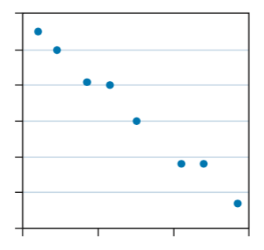
- Use words like positive, negative, linear, non-linear, strong, weak and moderate.
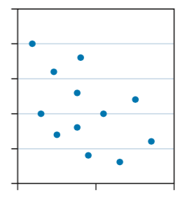

- _____________________________ b. __________________________
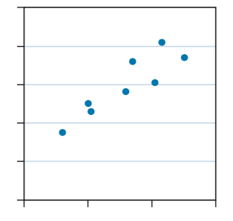

c. ____________________________

Q2) Using your knowledge of Bivariate data [1 + 2 = 3 marks]
- Define the term “Causal Relationship”

- Provide an example of a causal relationship, and explain how it is causal.
Q3) Identify the independent and dependent variable of the following pairs of bivariate data. [4 marks]

- Number of hours spent fishing and Number of fish caught

- Hours slept and Achieved test results

- Ice-cream sales and Daily temperature

- Price and Average distance run in sneakers

Q4) Charley recorded her height from the time she was 12 to 17. She plots a trend line on her data.
[1 + 1 + 2 +1 = 5 Marks]

- Using the trend line, make a prediction about how tall she will be at 20 years old?

- Do you think that your prediction is accurate?

- What do you think would be a reasonable height for charley at 20 years old? Why?

- How tall was Charley at 15 years?

Q5) A statistician was asked to investigate whether countries with higher levels of consumption of a particular foodstuff tended to have a higher death rate due to heart disease. The following information was obtained for 12 countries. [5+2+2+1=10 Marks]
 | CONSUMPTION OF FOODSTUFF  kg per person per year | DEATHS DUES TO HEART DISEASE  Per year per 100 000 of population
Country A | 57 | 299
Country B | 13 | 154
Country C | 51 | 152
Country D | 48 | 295
Country E | 35 | 208
Country F | 9 | 100
Country G | 21 | 175
Country H | 10 | 120
Country I | 46 | 202
Country J | 64 | 290
Country K | 38 | 156
Country L | 29 | 250


- Draw a scatterplot on the axis below.

- Fit a trend line to the data

- Are there any outliers in this set of data? How could you tell?

- Krystal says that a country where people eat 50kg’s of food would have 250,000 deaths in a year. Does this seem reasonable?

~END OF TEST~

